CprE 3810: Computer Organization and Assembly-Level Programming

Project Part 2 Report

Team Members: _______Drew Swanson___________________

_______Anthon Worsham__________________________

______________________________________________

Project Teams Group #:_______B3__________________

Refer to the highlighted language in the project 1 instruction for the context of the following questions.

[1.a] Come up with a global list of the datapath values and control signals that are required during each pipeline stage.

IF:
- s_Inst
- PC

ID:
- RegWrite
- s_Inst
- PC

EX:
- Jump_With_Register
- Imm_Gen
- rs1
- rs2
- ALU_Control
- ALU_Source
- Flag_Mux
- Shift_Amount
- Barrel_out

MEM:
- Branch
- Jump
- MemWrite
- AndLink
- ALUOut
- 4t1_andlink_out
- DMEMOut
- PC+4
- PC_or_jump

WB:
- PC-writeback
- MemToReg
- Write Data

[1.b.ii] high-level schematic drawing of the interconnection between components.
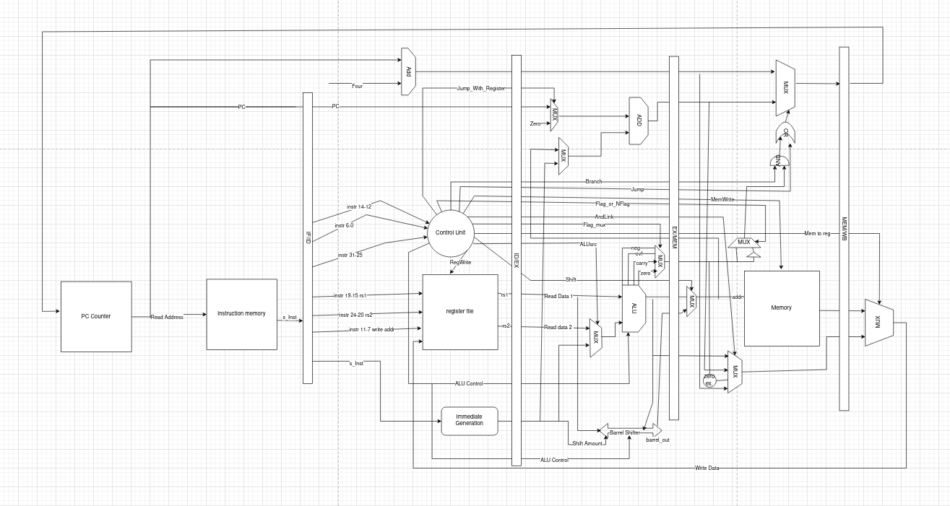
[1.c.i] include an annotated waveform in your writeup and provide a short discussion of result correctness.

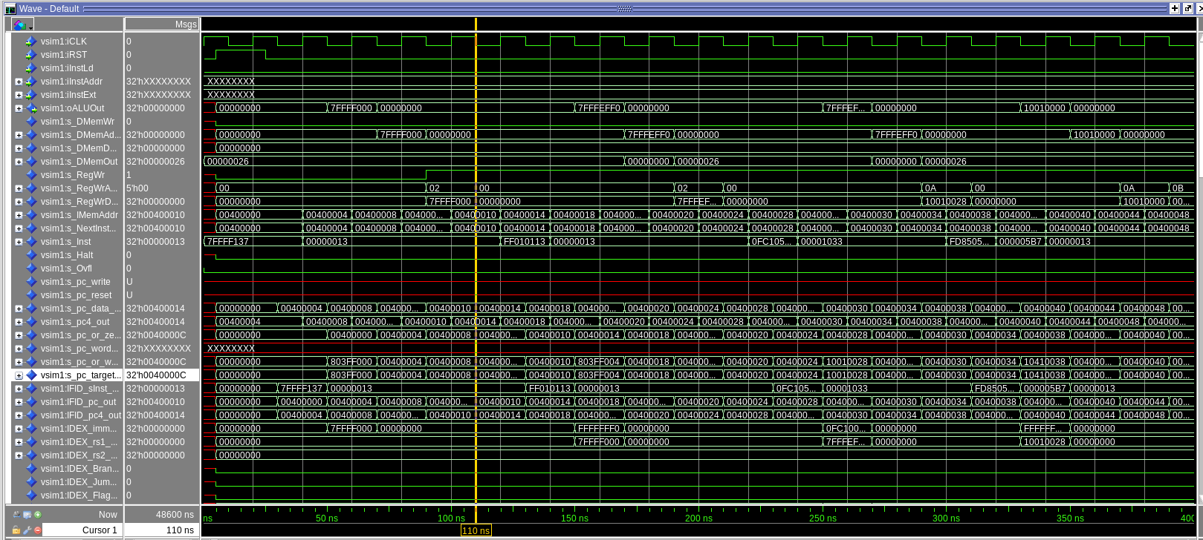
The annotated waveform demonstrates correct execution of the merge sort program on the pipelined processor. The program counter increments normally, showing continuous instruction flow with no stalls or deadlocks. Each pipeline stage (IF/ID, ID/EX, EX/MEM, MEM/WB) updates every cycle, confirming proper propagation of instructions through the pipeline. Stack activity,visible through repeating SW/LW patterns and changing data memory addresses, matches the recursive structure of merge sort, including function call setup, midpoint calculation, and return sequences. ALU outputs reflect correct index and midpoint computations, and memory reads/writes follow the expected behavior of copying and merging array segments. Together, these signals verify that branching, recursion, and memory operations execute correctly, confirming functional correctness of the merge sort implementation.

[1.c.ii] Include an annotated waveform in your writeup of two iterations or recursions of these programs executing correctly and provide a short discussion of result correctness. In your waveform and annotation, provide 3 different examples (at least one data-flow and one control-flow) of where you did not have to use the maximum number of NOPs.
The annotated waveform shows two full recursive calls of mergeSort executing correctly: the PC advances through each call, the stack pointer decreases and increases in matched sw/lw sequences, and each call returns to the correct PC address. ALU outputs confirm correct midpoint calculations, and data-memory activity matches the expected copy and merge steps. The waveform also highlights three places where fewer than the maximum NOPs were required: (1) the midpoint arithmetic chain (sub → srli → add) executes with only a single NOP before the result is consumed; (2) the load-then-store sequence in the copy loops uses only minimal spacing because address updates naturally separate the load and store; and (3) branches in the merge and copy loops (bge) require fewer NOPs yet still redirect the PC cleanly without corrupting pipeline registers.
[1.d] report the maximum frequency your software-scheduled pipelined processor can run at and determine what your critical path is (specify each module/entity/component that this path goes through).

Max Freq: 48.57 mGhz
Critical Path: Branch Unsigned

[2.a.ii] Draw a simple schematic showing how you could implement stalling and flushing operations given an ideal N-bit register.
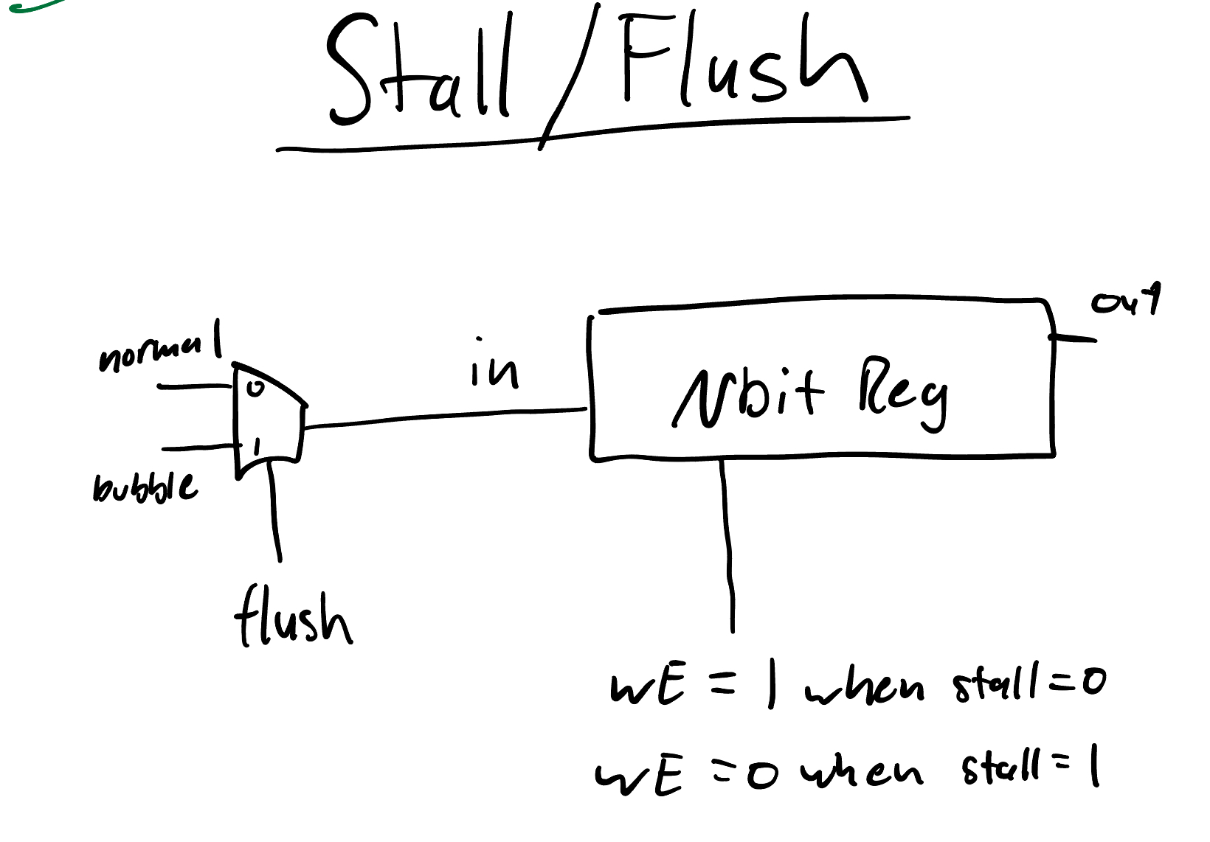
[2.a.iii] Create a testbench that instantiates all four of the registers in a single design. Show that values that are stored in the initial IF/ID register are available as expected four cycles later, and that new values can be inserted into the pipeline every single cycle. Most importantly, this testbench should also test that each pipeline register can be individually stalled or flushed.

[2.b.i] list which instructions produce values, and what signals (i.e., bus names) in the pipeline these correspond to.
add → s_alu_out, s_exec_result, EXMEM_ALUOut_out, s_4t1_and_link_out, MEMWB_4t1AndLink_out, s_RegWrData
sub : same signals as add
and : same signals as add
or : same signals as add
xor : same signals as add
sll : s_out_shifted_data, s_exec_result, EXMEM_ALUOut_out, s_4t1_and_link_out, MEMWB_4t1AndLink_out, s_RegWrData
srl : same signals as sll
sra : same signals as sll
addi : s_alu_out, s_exec_result, EXMEM_ALUOut_out, s_4t1_and_link_out, MEMWB_4t1AndLink_out, s_RegWrData
andi : same signals as addi
ori : same signals as addi
xori : same signals as addi
slli : s_out_shifted_data, s_exec_result, EXMEM_ALUOut_out, s_4t1_and_link_out, MEMWB_4t1AndLink_out, s_RegWrData
srli : same signals as slli
srai : same signals as slli
slt : s_slt_sltiu_mux_out, s_4t1_and_link_out, MEMWB_4t1AndLink_out, s_RegWrData
sltu : same signals as slt
slti : same signals as slt
sltiu : same signals as slt
lui : s_extended_imm, IDEX_immGen_out, s_4t1_and_link_out, MEMWB_4t1AndLink_out, s_RegWrData
auipc : s_pc_or_word_adder_out, s_pc_target_masked, EXMEM_PC_jump_adder_out, s_4t1_and_link_out, MEMWB_4t1AndLink_out, s_RegWrData
jal : EXMEM_PC4_out, s_4t1_and_link_out, MEMWB_4t1AndLink_out, s_RegWrData
jalr : same signals as jal
Instructions that produce load values:
lw : s_DMemOut, MEMWB_DMEM_out, sMemSlice, s_RegWrData
Instructions that produce memory write values:
sw : IDEX_rs2_out, EXMEM_RS2_out, s_DMemData
Instructions that produce PC values:
All control-flow instructions : s_pc4_out, s_pc_or_word_adder_out, s_pc_target_masked, EXMEM_PC_jump_adder_out, pc_writeback_MEMWB_input, s_pc_data_in

[2.b.ii] List which of these same instructions consume values, and what signals in the pipeline these correspond to.

add : consumes s_out_rs1, s_out_rs2, then IDEX_rs1_out, IDEX_rs2_out, then input_A, input_B
sub : same signals as add
and : same signals as add
or : same signals as add
xor : same signals as add
sll : consumes s_out_rs1 (shifter data), s_out_rs2(4 downto 0) (shift amount), then IDEX_rs1_out, s_rs2_or_imm_mux_out(4 downto 0)
srl : same signals as sll
sra : same signals as sll
addi : consumes s_out_rs1, then IDEX_rs1_out
andi : same signals as addi
ori : same signals as addi
xori : same signals as addi
slli : consumes s_out_rs1, immediate from s_extended_imm, then IDEX_rs1_out, s_rs2_or_imm_mux_out(4 downto 0)
srli : same signals as slli
srai : same signals as slli
slt : consumes s_out_rs1, s_out_rs2, then IDEX_rs1_out, IDEX_rs2_out
sltu : same signals as slt
slti : consumes s_out_rs1, immediate s_extended_imm, then IDEX_rs1_out, IDEX_immGen_out
sltiu : same signals as slti
auipc : consumes PC: IFID_pc_out, then IDEX_PC_out
jalr : consumes s_out_rs1, then IDEX_rs1_out
sw : consumes s_out_rs1 (address base), s_out_rs2 (store data), then IDEX_rs1_out, IDEX_rs2_out, and address from s_exec_result/EXMEM_ALUOut_out
lw : consumes s_out_rs1, then IDEX_rs1_out for address calculation
beq, bne, blt, bge, etc. : consume s_out_rs1, s_out_rs2, then IDEX_rs1_out, IDEX_rs2_out, and flags in EX via s_flag_mux_out
jal : consumes no rs1/rs2 (only PC): IFID_pc_out, IDEX_PC_out
Signals where consumption occurs:
Register file outputs: s_out_rs1, s_out_rs2
ID/EX pipeline register outputs: IDEX_rs1_out, IDEX_rs2_out, IDEX_immGen_out, IDEX_PC_out
ALU inputs: input_A, input_B
Shifter inputs: IDEX_rs1_out, s_rs2_or_imm_mux_out(4 downto 0)
Branch comparator inputs: via ALU flags s_flag_mux_out, EXMEM_ALU_Flag_out
Store data path: IDEX_rs2_out, EXMEM_RS2_out
Address path for loads/stores: s_exec_result, EXMEM_ALUOut_out

[2.b.iii] generalized list of potential data dependencies. From this generalized list, select those dependencies that can be forwarded (write down the corresponding pipeline stages that will be forwarding and receiving the data), and those dependencies that will require hazard stalls.

DEPENDENCIES THAT CAN BE FORWARDED

ALU → ALU
Forward from EX/MEM → EX
Forward from MEM/WB → EX
ALU → branch
Forward from EX/MEM → EX
Forward from MEM/WB → EX
ALU → store (data)
Forward from EX/MEM → MEM
load → ALU (if ≥1 instruction later)
Forward from MEM/WB → EX
load → branch (if ≥1 instruction later)
Forward from MEM/WB → EX
load → store (data) (if your memory allows it)
Forward from MEM/WB → MEM

DEPENDENCIES THAT REQUIRE A STALL
load → ALU (next instruction)
load → branch (next instruction)
load → store (data) (next instruction, if forwarding to MEM is not supported)
These require 1 stall (bubble inserted into EX).

[2.b.iv] global list of the datapath values and control signals that are required during each pipeline stage

[2.c.i] list all instructions that may result in a non-sequential PC update and in which pipeline stage that update occurs.

[2.c.ii] For these instructions, list which stages need to be stalled and which stages need to be squashed/flushed relative to the stage each of these instructions is in.

[2.d] implement the hardware-scheduled pipeline using only structural VHDL. As with the previous processors that you have implemented, start with a high-level schematic drawing of the interconnection between components.

[2.e – i, ii, and iii] In your writeup, show the QuestaSim output for each of the following tests, and provide a discussion of result correctness. It may be helpful to also annotate the waveforms directly.

[2.e.i] Create a spreadsheet to track these cases and justify the coverage of your testing approach. Include this spreadsheet in your report as a table.

[2.e.ii] Create a spreadsheet to track these cases and justify the coverage of your testing approach. Include this spreadsheet in your report as a table.

[2.f] report the maximum frequency your hardware-scheduled pipelined processor can run at and determine what your critical path is (specify each module/entity/component that this path goes through).

